Dashboard overview

Figure 1. Main Dashboard. This is the first screen that shows up when you visit the dashboard. It provides a general overview (or a summary) of your metrics across all sessions.
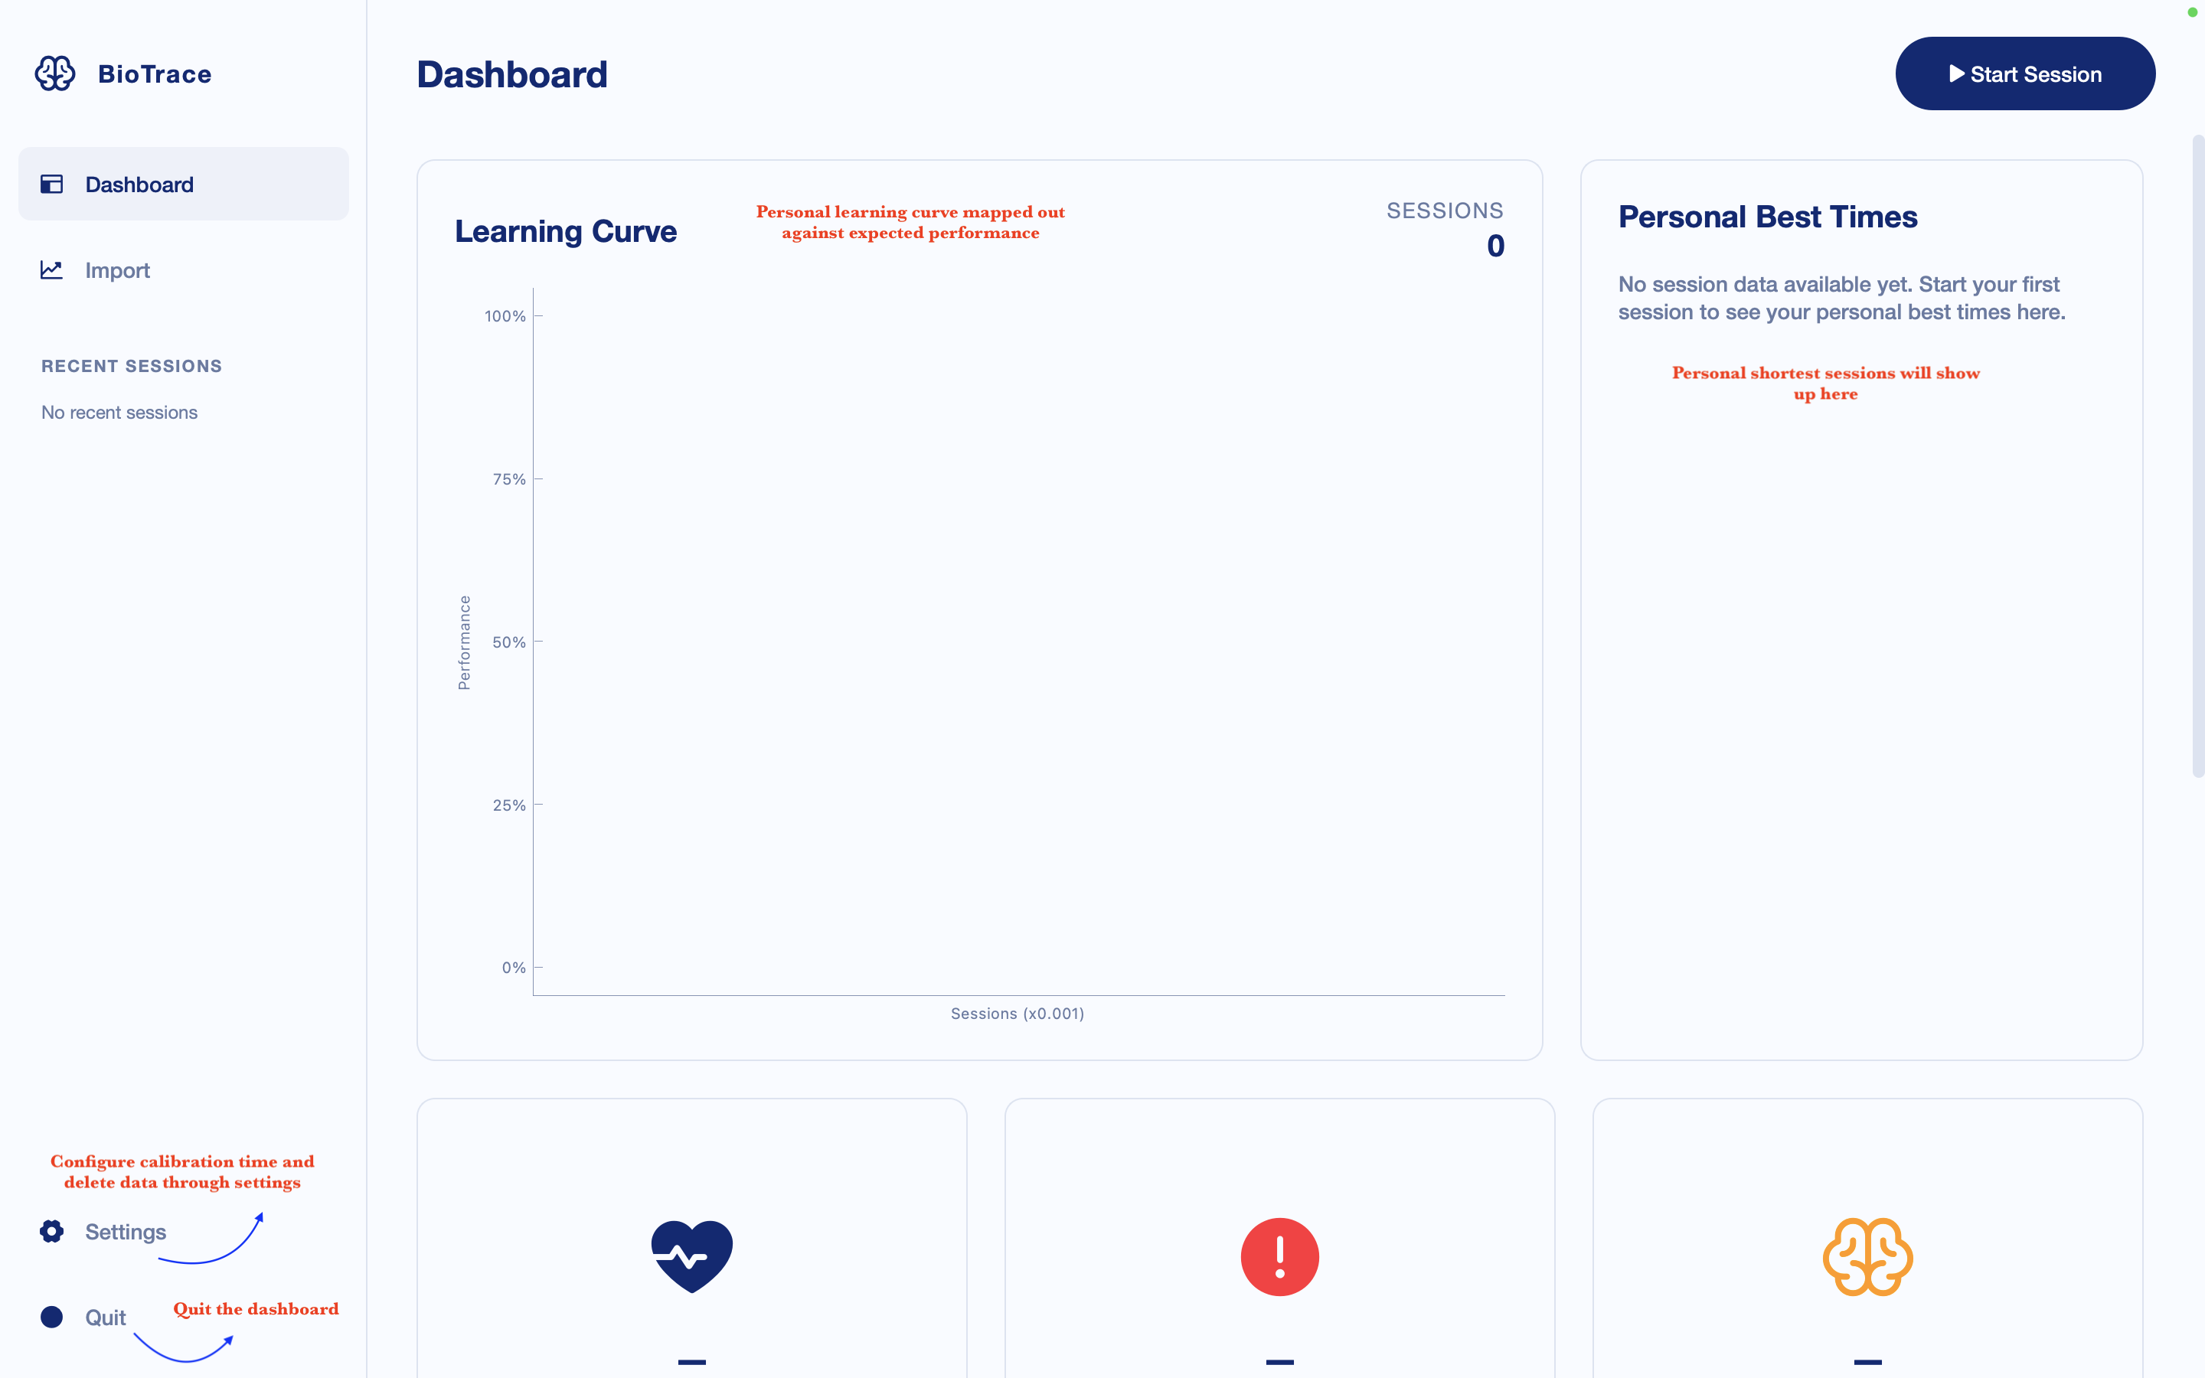

Figure 2. Main dashboard continued.
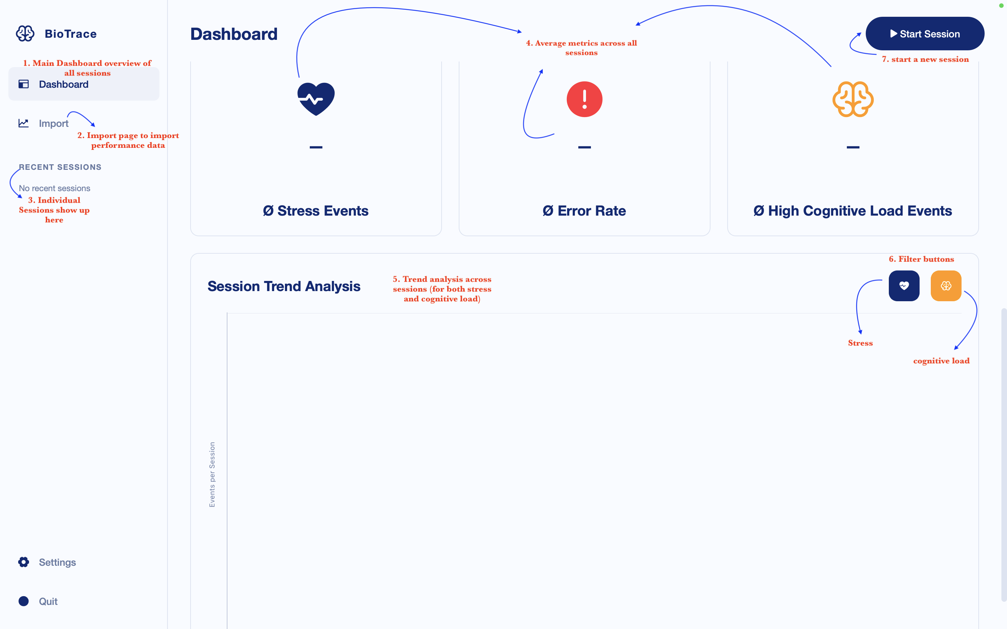

Figure 3. Main dashboard continued.
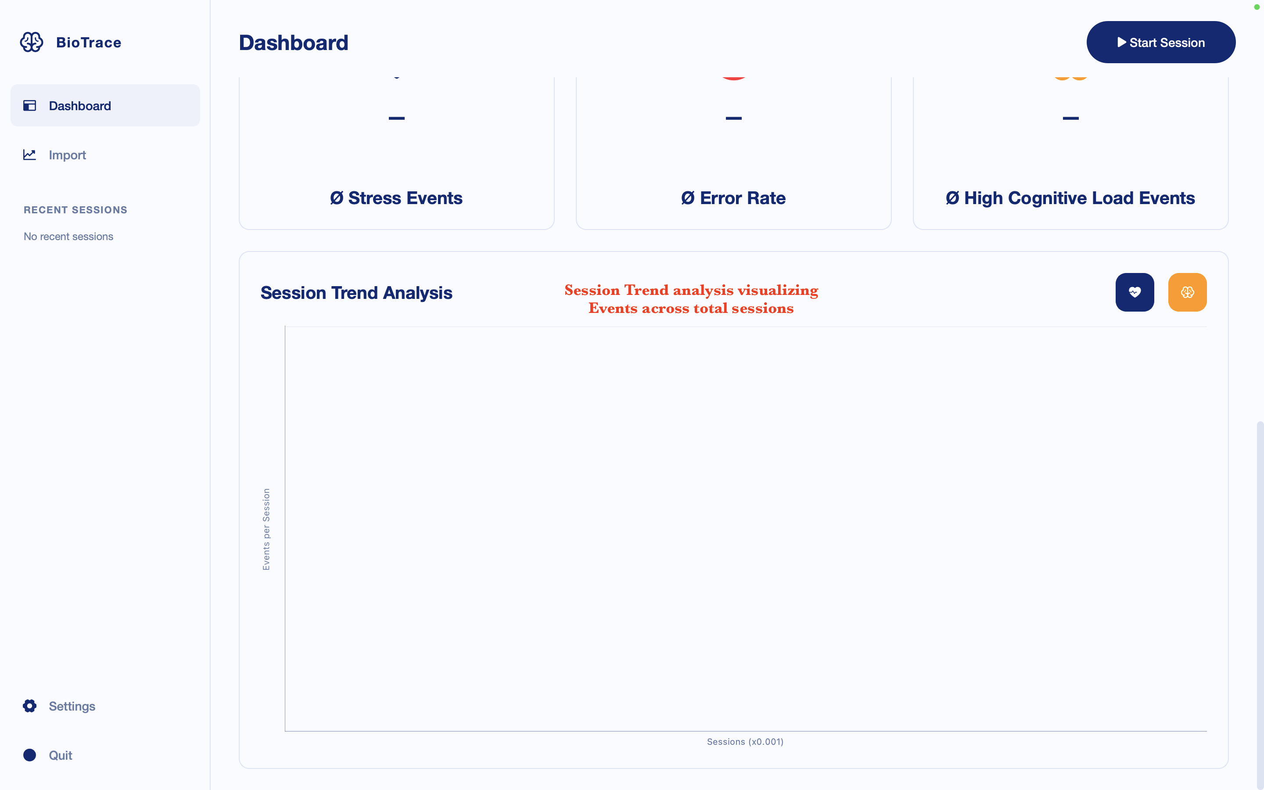

Figure 3. Import page. In this tab you can import existing performance data per task to generate a learning curve.
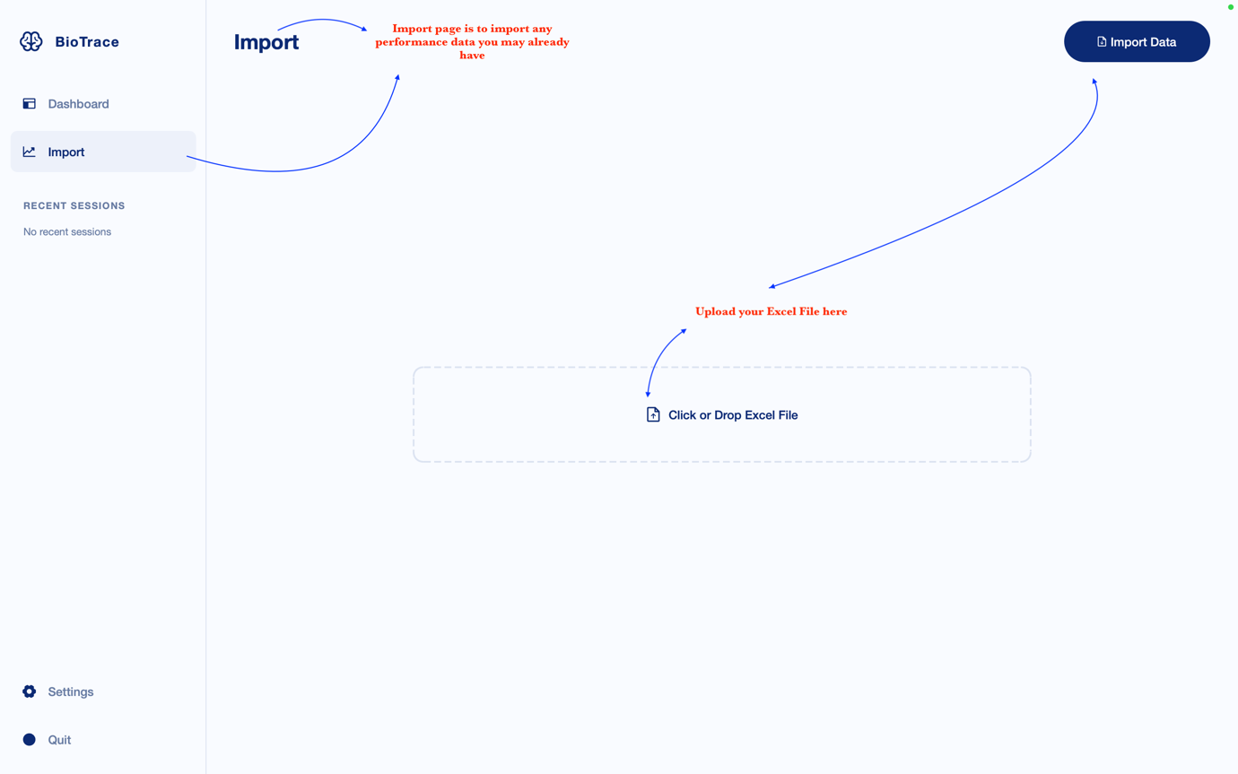

Figure 3. Import page output. The generated learning curve looks similar to the one below.
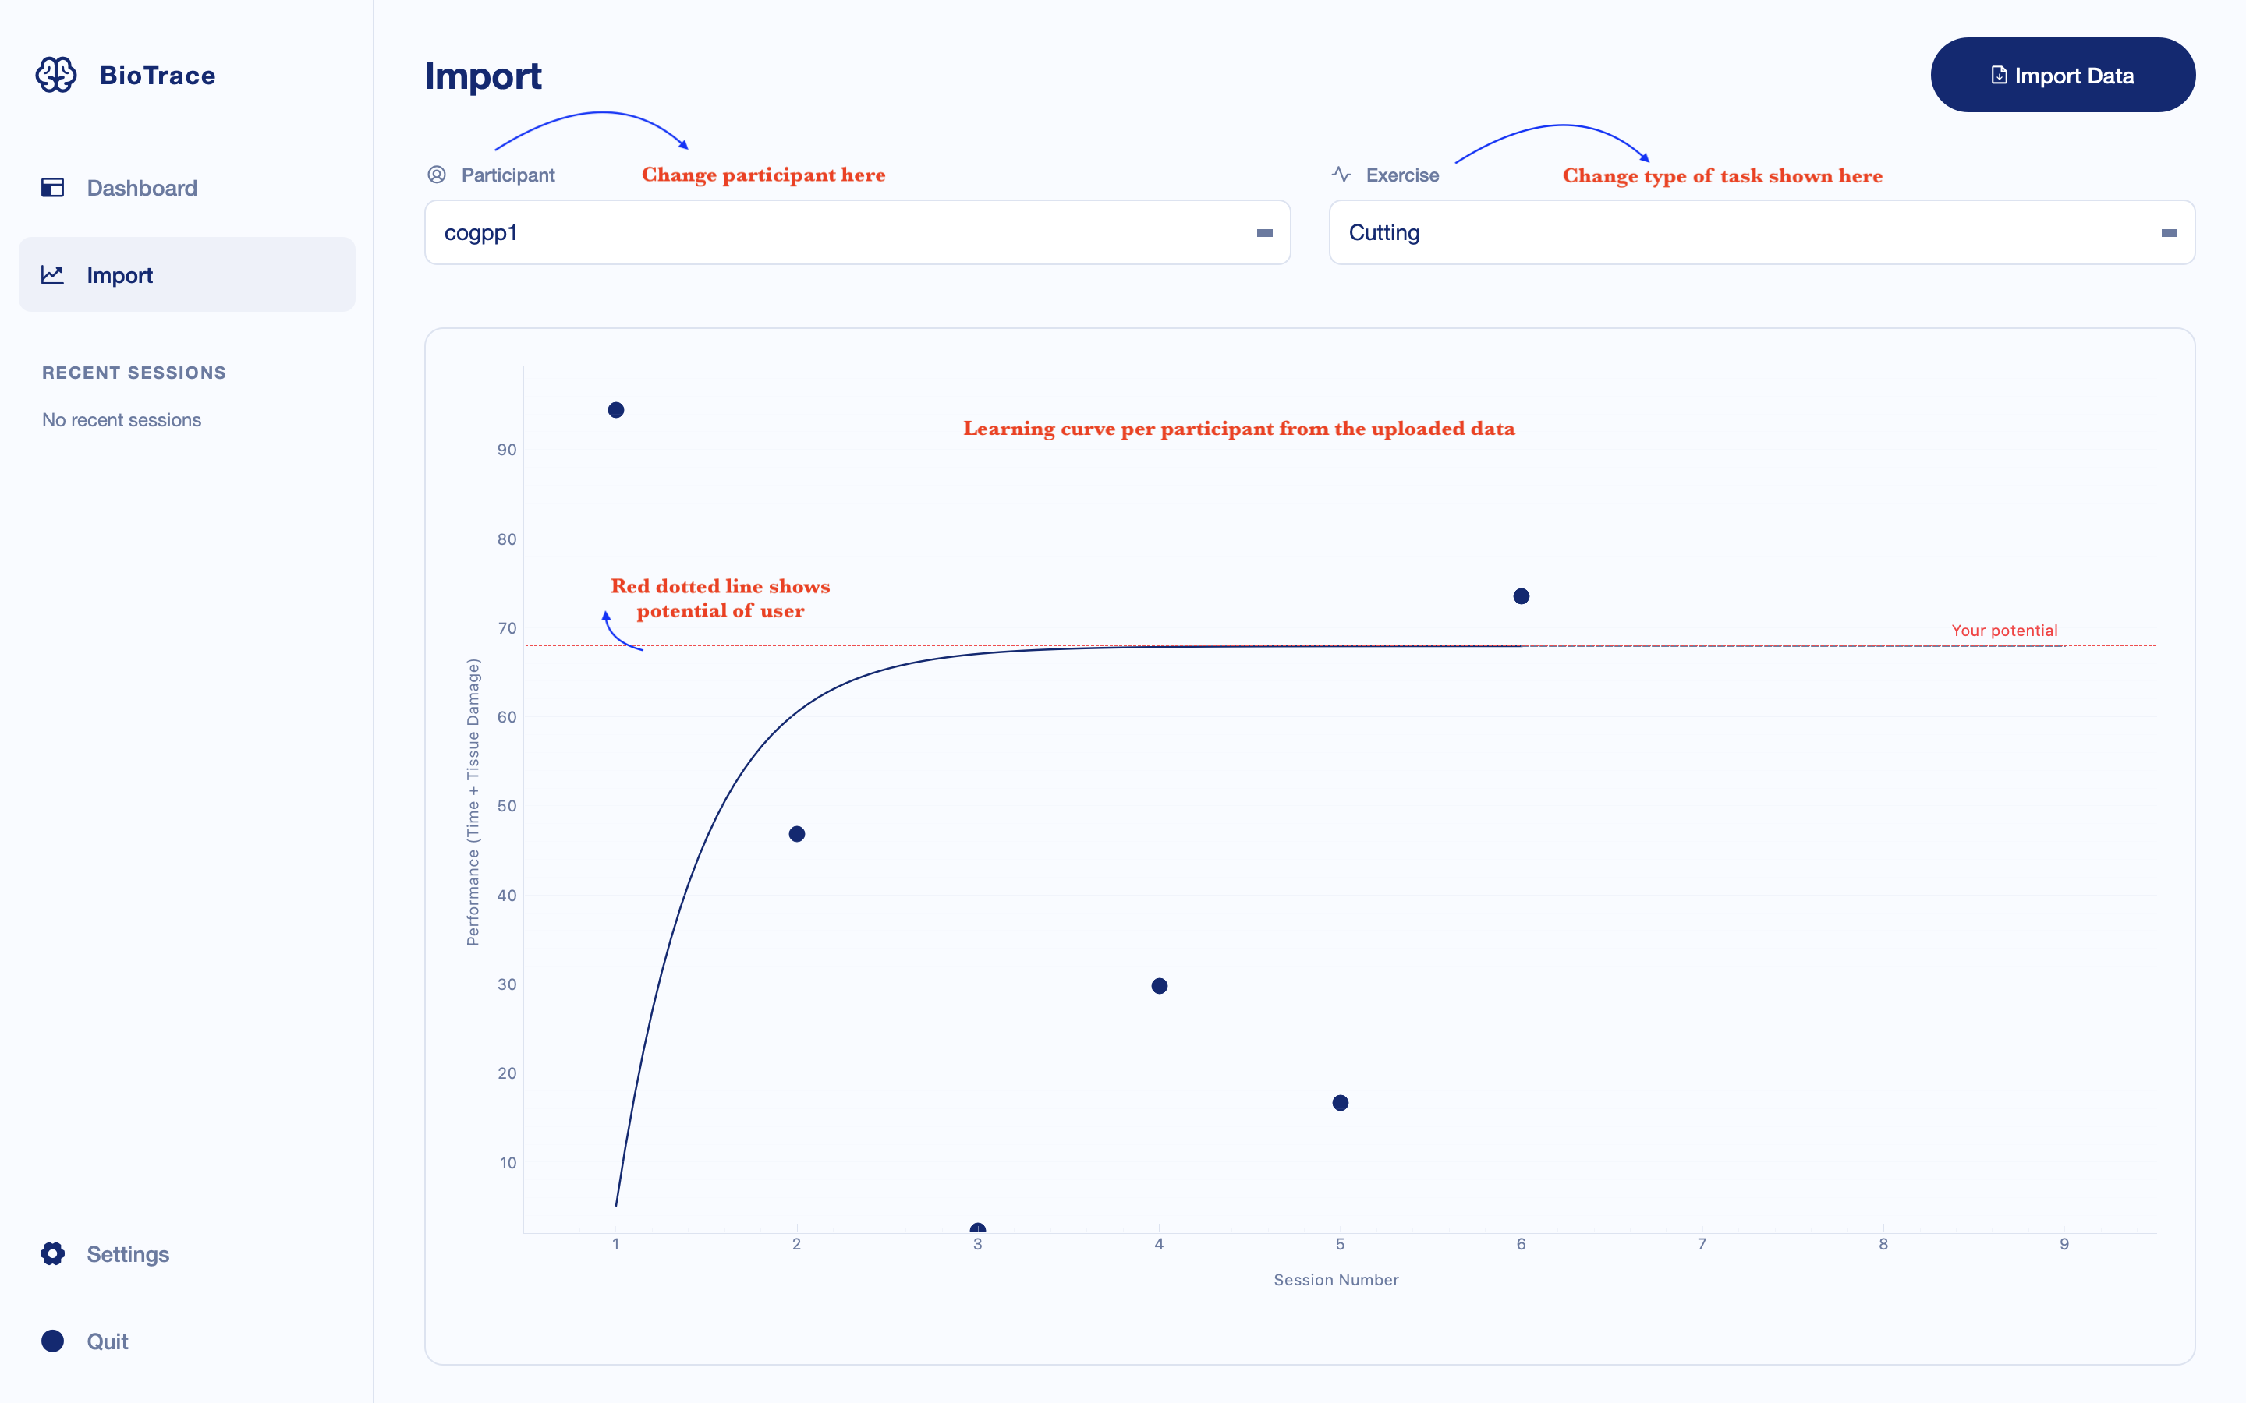

Figure 4. The live dashboard view. After calibrating and starting the session, the live dashboard view shows up. Here you can view your HRV, change in pupil dilation, error rates, along with stress and cognitive load levels as the session progresses.

